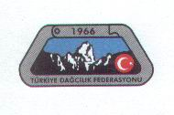
TÜRKİYE DAĞCILIK FEDERASYONU
Turkish Mountaineering Federation

TDF/ / /2014

Dear President,

You and your delegation are cordially invited to the 15th International Victory climbing to Mount Ağrı (Ararat) which will be held on August 27-31, 2014.
We would be pleased if you and your Federation members attended to this activity.

Yours sincerely,
Alaattin KARACA
President of Turkish Mountaineering Federation

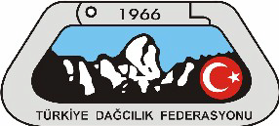
15th INTERNATIONAL VICTORY CLIMBING TO
MOUNT AĞRI
28–31 AUGUST 2014, DOĞUBEYAZIT/AĞRI

GENERAL INFORMATION: 15th International Victory Climbing to Mount Ağrı, organized by Turkish Mountaineering Federation (TMF), will be executed on August 28-31, 2014. TMF has honor to invite (4) mountaineers of your Federation / Association.
Due to the limited capacity and hard weather conditions, TMF has right to change the program and to keep the number of nominees at an acceptable level if they are more than expected.
PARTICIPANTS: This invitation is sent to International Federations and Associations and from each of them TMF kindly asks to nominate four (4) mountaineers not later than August 18, 2014.
The Mount Ağrı with its (5165) meters altitude needs at least basic experience concerning snow and glacier climbing techniques but also, necessary camp and climbing equipment such as sleeping bag, tent, ice axe, crampons (if you want to choose glacier route) etc.
Please send us back personnel information of your mountaineers (not more than 4) with the copies of passports, and by filling out the “application forms” attached to the end of this e-mail.
HOW TO REACH DOĞUBEYAZIT : You can find cheap flight from İstanbul to Ağrı or Iğdır . There are approximately 2 direct flights from Istanbul to Ağrı (THY), and 2 flights from Ankara to Ağrı or Iğdır every day. It is important to buy the tickets as early as possible because the tickets will be cheaper, then. The tickets are expensive during summer months. You can find below the web addresses for buying the tickets. Be carefully there are 2 airports in Istanbul IST (Atatürk Airport) http://www.ataturkairport.com/en-EN/Pages/Main.aspx) and, SAW(SabihaGökcenairport)http://www.sgairport.com/havaalani/eng/start.asp )
Airline Companies (2 hour 10 min. from İstanbul to Ağrı or Iğdır)
THY http://www.turkishairlines.com
Pegasus http://www.flypgs.com/en/
Onur Air http://www.onurair.com.tr/default_eng.aspx
Anadolu Jet http://www.anadolujet.com/aj-EN/index.aspx
You can easily find mini bus and/or busses in front of the Ağrı, Iğdır airports from Ağrı, Iğdır to Doğubeyazıt city center.
On the other hand we can plan a minibus for carrying the participants from Ağrı, Iğdır to Doğubeyazıt two times a day. It is necessary for the participants to give their flying Schedule to our Federation not later than four weeks before the flying time.

Bus Companies (aprox. 20 hours from İstanbul to Doğubeyazıt)
Ulusoy http://www.ulusoy.com.tr/
Metro http://www.metroturizm.com.tr/en/index.htm
FINANCIAL CONDITIONS: All organizational services, official permission and guidance will be provided by TMF. All travel and accommodation expenses will be covered by each participant. All delegations are kindly asked to bring their national flags together with them.
Information about Doğubayazıt: It is set on a stark treeless plain between ranges of craggy mountains, and it is the last Turkish town on the highway to Iran. The border takes 35km (22 miles) to the east. Doğubayazıt is 1950 meters/6400 feet. The striking 18th-century Ishak Pasha Palace is 5 km (3 miles) to the east of Doğubayazıt.
You may be here to gaze upon legendary Mount Ararat, or the giant meteor crater 4 km (2.5 miles) west of the border, or Ancient Bayazıt, the foundations of a settlement thought to date from Urartian times (800 BC).
Mount Ağrı (Ararat): (Turkish: Ağrı, see below other: names and etymology) is a snow-capped, dormant volcanic cone in Turkey. It has two peaks: Greater Ağrı (Ararat) (the highest peak in Turkey, and the entire Armenian plateau with an elevation of 5,137 m or 16,854 ft.) and Lesser Ağrı (Ararat) (with an elevation of 3,896 m or 12,782 ft.).The Ararat massif is about 40 km (25 mi) in diameter. The Iran-Turkey boundary skirts east of Lesser Ararat, the lower peak of the Ararat massif. It was in this area that, by the Tehran Convention of 1932, a border change was made in Turkey's favors, allowing it to occupy the eastern flank of Lesser Ararat.^{[5]}
Mount Ararat in Judeo-Christian tradition is associated with the "Mountains of Ararat" where, according to the book of Genesis, Noah's ark came to rest.
It also plays a significant role in Armenian culture and irredentism. The mountain can be seen on the Coat of arms of Armenia.
Day 1 Dogubayazit to Mount Ağrı first Camp:
Starting of this trip will be from Van airport. You will meet our staff in the airport to transfer the group our starting point for the expedition Mount Ağrı plain.
Have our lunch in Dogubayazit and after the gear check we will be transferred to the 2100 m Elli village in Mount Ararat to start our expedition.
Mules will carry our expedition equipment up to the nomadic camping area in 2850 m or 3200m. Here we will be staying with local villagers and enjoy all day with discovering the people and mountain.
Day 2 4200 Camp at Mount Ağrı:
The second day, we will move our tents and equipment from 3200 m. or Sandy camp to 4200 m. camp area. Well after the setting our new camp we will ascent to approximately 4700 m. to acclimate for the next day summit ascent. If the weather is visible you will see the gorge between little and great Ağrı Mountains and watch the Ağrı plain.
After having our meal at high altitude we will return to our new camp 4200 m.
Day 3 Mount Ararat Summit Day:
This day we will wake up very early before the sun rises up. We will have our little breakfast in the moon light with seeing the city lights down in the plane of Mount Ararat.
Start our ascent with in moon light and on our half way to the summit we’ll have a brake and at this time you will see the shadow of the mountain in the plane. Before we get to the summit we will meet with the biggest glacier of Turkey at this point we will use our crampons till to the summit approximately 300 m.
When we get to the summit of 5137 m you will feel a empty space in your heart in same time happens of to being in the summit.
After the celebration of to being the summit we will start trek down to the 4200 m. Or base camp. We will spend our time in the 3200 m. relaxing.
Day 4 Back to The Dogubayazit:
The day of saying goodbye to the Holly Mount Ararat; after having our breakfast we will walk down from 3200 m base camp down to 2100 m. to get the transport to the hotel in the center of the town.
Useful Links
www.tdf.org.tr www.thy.com
http://tr.wikipedia.org/wiki/Ka%C3%A7kar_Da%C4%9Flar%C4%B1
http://www.dmi.gov.tr/tahmin/il-ve-ilceler.aspx?m=RIZE#sfB
Mount Ağrı Detailed Peak Rotation
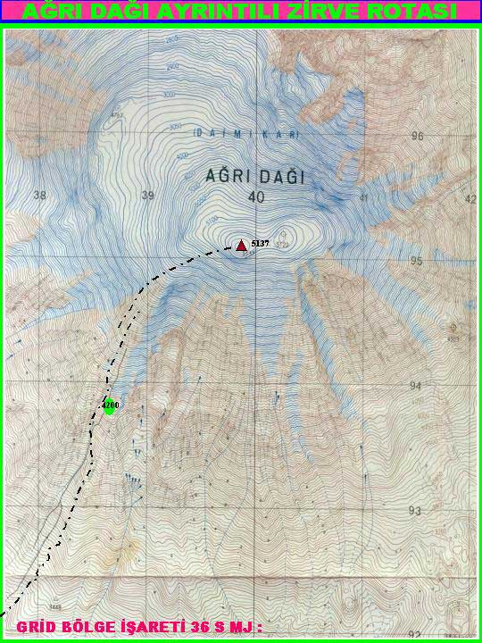
Mount Ağrı Climbing Program:
August 27, 2014 Gatering together in Doğubayazıt Gençlik Spor İlçe Müdürlüğü (Directorship of Youth, Sport Centre).
August 28, 2014 08.30 Move to 3200 m. Camp area.
August 29, 2014 08.30 Move to 4200 m. Camp area.
August 30, 2014 Climbing to the Peak and return to 3200 m. Camp.
August 31, 2014 08.00 Return to Doğubayazıt. At 18.00 Certificate Ceremony and the end of the activity.
IMPORTANT NOTICE: The Turkish Mountaineering Federation will give information about the nature of climbing at 19:00, on August 27, 2014.

EMAIL ADRES:
"Turkish Mountaineering Federation" <tdf1966@hotmail.com>,

15 th INTERNATIONAL VICTORY CLIMBING TO
MOUNT AĞRI
28–31 AUGUST 2014, DOĞUBEYAZIT/AĞRI
APPLICATION FORM

COUNTRY :

Name of Association / Federation :
Phone : |  | Fax :
E-Mail :
Names of Participants

Name | Surname | Address | Phone
Name | Surname | Address | Phone
Date of Arrival :
Date of Departure :
Type of Room Single Double Room Room for 3
Flight Details (Flight Number , Arrival and Departure Date) :

Date , Signature of
President or Secretary
General and Stamp of Association

Please return this form to Turkish Mountaineering Federation until 30 july , 2012
By Fax : 00 90 312 310 15 78 – Phone : 00 90 312 311 91 20
E-Mail : tdf1966@hotmail.com
Address : Gençlik ve Spor Genel Müdürlüğü Dağcılık Federasyonu Başkanlığı Ulus İş Hanı A
Blok Kat 4 Ulus / Ankara / TURKEY

